**DBMS Lab**



Name: **Soham Das**

Section: **A1**

Roll No: **002311001004**

**Assignment - 3**

**IT-UG2**

**Question: Consider a BANK database. Each bank can have multiple branches, and each branch can have multiple accounts and loans. Assumptions also can be made. Design an ER diagram and database schema for the system. Specify the primary key, foreign key and other constraints for all required tables. Draw the ER diagram in MS Word.**

ER Diagram

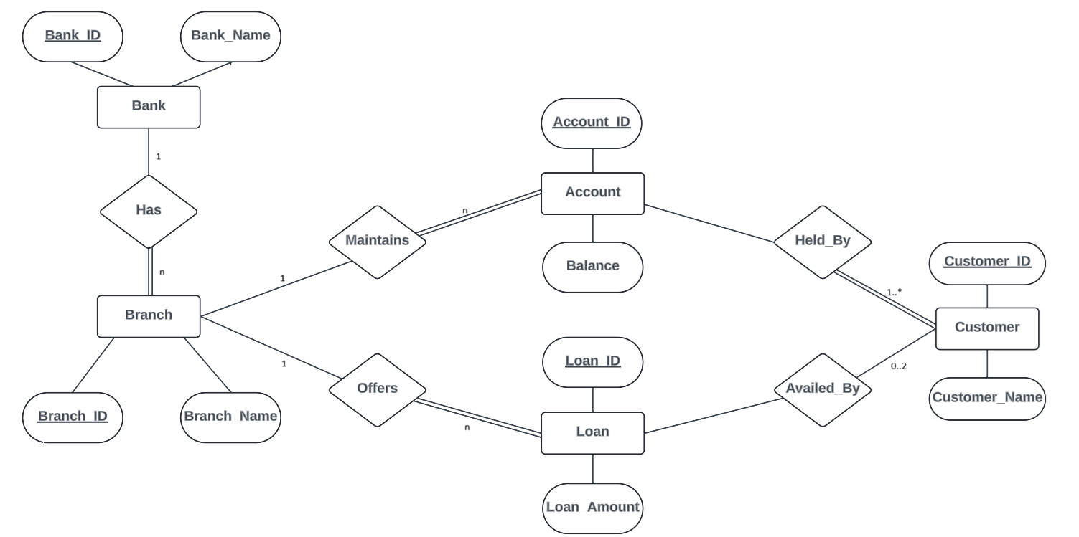

Database Schema

1. Insert at least five tuples in each table.

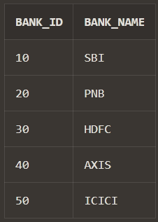--BANK Table

CREATE TABLE Bank (

Bank_ID NUMBER (2) PRIMARY KEY,

Bank_Name VARCHAR2(25) NOT NULL);

INSERT INTO Bank VALUES (10, 'SBI');

INSERT INTO Bank VALUES (20, 'PNB');

INSERT INTO Bank VALUES (30, 'HDFC');

INSERT INTO Bank VALUES (40, 'AXIS');

INSERT INTO Bank VALUES (50, 'ICICI');

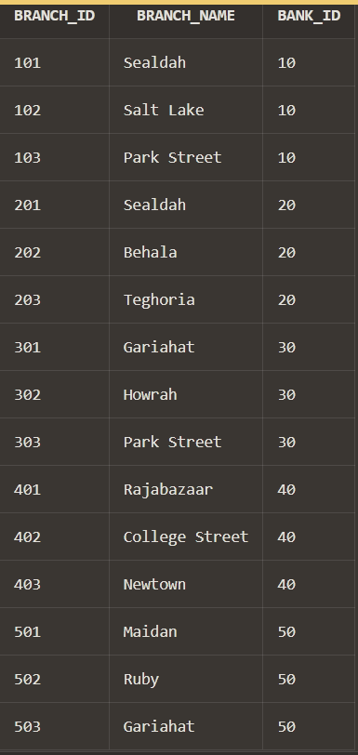--BRANCH Table

CREATE TABLE Branch (

Branch_ID NUMBER (3) PRIMARY KEY,

Branch_Name VARCHAR2(40) NOT NULL,

Bank_ID NUMBER (2),

FOREIGN KEY (Bank_ID) REFERENCES Bank(Bank_ID));

INSERT INTO Branch VALUES (101, 'Sealdah', 10);

INSERT INTO Branch VALUES (102, 'Salt Lake', 10);

INSERT INTO Branch VALUES (103, 'Park Street', 10);

INSERT INTO Branch VALUES (201, 'Sealdah', 20);

INSERT INTO Branch VALUES (202, 'Behala', 20);

INSERT INTO Branch VALUES (203, 'Teghoria', 20);

INSERT INTO Branch VALUES (301, 'Gariahat', 30);

INSERT INTO Branch VALUES (302, 'Howrah', 30);

INSERT INTO Branch VALUES (303, 'Park Street', 30);

INSERT INTO Branch VALUES (401, 'Rajabazaar', 40);

INSERT INTO Branch VALUES (402, 'College Street', 40);

INSERT INTO Branch VALUES (403, 'Newtown', 40);

INSERT INTO Branch VALUES (501, 'Maidan', 50);

INSERT INTO Branch VALUES (502, 'Ruby', 50);

INSERT INTO Branch VALUES (503, 'Gariahat', 50);

--CUSTOMER Table

CREATE TABLE Customer (

Customer_ID NUMBER (4) PRIMARY KEY,

Customer_Name VARCHAR(100) NOT NULL);

INSERT INTO Customer VALUES (1001, 'Ramesh');

INSERT INTO Customer VALUES (1002, 'Suresh');

INSERT INTO Customer VALUES (1003, 'Pakeya');

INSERT INTO Customer VALUES (2001, 'Charan');

INSERT INTO Customer VALUES (2002, 'Ram');

INSERT INTO Customer VALUES (2003, 'Pankaj');

INSERT INTO Customer VALUES (3001, 'Soham');

INSERT INTO Customer VALUES (3002, 'Debodit');

INSERT INTO Customer VALUES (3003, 'Anuska');

INSERT INTO Customer VALUES (4001, 'Prama');

INSERT INTO Customer VALUES (4002, 'Rishika');

INSERT INTO Customer VALUES (4003, 'Sayani');

INSERT INTO Customer VALUES (5001, 'Tanish');

INSERT INTO Customer VALUES (5002, 'Aman');

INSERT INTO Customer VALUES (5003, 'Neel');

--ACCOUNT Table

CREATE TABLE Account (

Account_ID NUMBER (11) PRIMARY KEY,

Balance DECIMAL(10, 2),

Customer_ID NUMBER (4),

Branch_ID NUMBER (3),

FOREIGN KEY (Branch_ID) REFERENCES Branch(Branch_ID) on DELETE CASCADE,

FOREIGN KEY (Customer_ID) REFERENCES Customer(Customer_ID) on DELETE CASCADE);

Insert into ACCOUNT values (55690129329, 35486.12, 1001, 101);

Insert into ACCOUNT values (89545237546, 1234.56, 1003, 101);

Insert into ACCOUNT values (54321987654, 98765.43, 1002, 102);

Insert into ACCOUNT values (39800005552, 45678.90, 1003, 103);

Insert into ACCOUNT values (59498307311, 2345.57, 2001, 202);

Insert into ACCOUNT values (65592459895, 67890.12, 2002, 202);

Insert into ACCOUNT values (71875151611, 54321.98, 2001, 201);

Insert into ACCOUNT values (77975635172, 8765.43, 2003, 203);

Insert into ACCOUNT values (84531363466, 34567.89, 3001, 302);

Insert into ACCOUNT values (46372949259, 78901.23, 3002, 301);

Insert into ACCOUNT values (82273579151, 65432.10, 4001, 401);

Insert into ACCOUNT values (57679662463, 4321.98, 4002, 402);

Insert into ACCOUNT values (90680460457, 21098.76, 4003, 403);

Insert into ACCOUNT values (18567978674, 3456.78, 3003, 403);

Insert into ACCOUNT values (94720840720, 67789.01, 5001, 501);

Insert into ACCOUNT values (10346725987, 54321.10, 5002, 503);

Insert into ACCOUNT values (35487204793, 9876.54, 5003, 503);

Insert into ACCOUNT values (28645816408, 123456.67, 5001, 503);

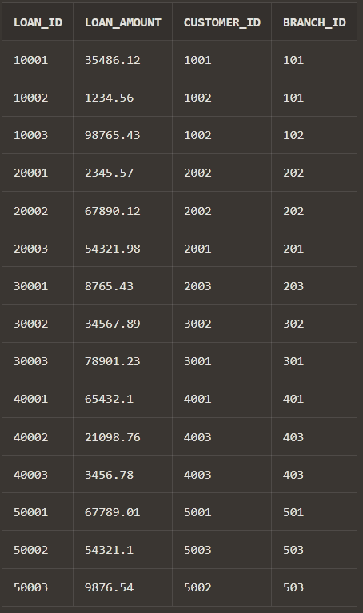--LOAN Table

CREATE TABLE Loan (

Loan_ID NUMBER (5) PRIMARY KEY,

Loan_Amount DECIMAL(10, 2),

Customer_ID NUMBER (4),

Branch_ID NUMBER (3),

FOREIGN KEY (Branch_ID) REFERENCES Branch(Branch_ID) on DELETE CASCADE,

FOREIGN KEY (Customer_ID) REFERENCES Customer(Customer_ID) ON DELETE CASCADE);

Insert into LOAN values (10001, 35486.12, 1001, 101);

Insert into LOAN values (10002, 1234.56, 1002, 101);

Insert into LOAN values (10003, 98765.43, 1002, 102);

Insert into LOAN values (20001, 2345.57, 2002, 202);

Insert into LOAN values (20002, 67890.12, 2002, 202);

Insert into LOAN values (20003, 54321.98, 2001, 201);

Insert into LOAN values (30001, 8765.43, 2003, 203);

Insert into LOAN values (30002, 34567.89, 3002, 302);

Insert into LOAN values (30003, 78901.23, 3001, 301);

Insert into LOAN values (40001, 65432.10, 4001, 401);

Insert into LOAN values (40002, 21098.76, 4003, 403);

Insert into LOAN values (40003, 3456.78, 4003, 403);

Insert into LOAN values (50001, 67789.01, 5001, 501);

Insert into LOAN values (50002, 54321.10, 5003, 503);

Insert into LOAN values (50003, 9876.54, 5002, 503);

1. Every customer must have at least one account but is restricted to at most two loans at a time.

ALTER table CUSTOMER ADD Account_ID number (11) NOT NULL

ADD CONSTRAINT FK FOREIGN KEY (ACCOUNT_ID) REFERENCES ACCOUNT (ACCOUNT_ID);

CREATE TRIGGER MaxLoansPerCustomer

BEFORE INSERT ON Loan

FOR EACH ROW

BEGIN

DECLARE loan_count INT;

SELECT COUNT(*) INTO loan_count

FROM Loan

WHERE CustomerID = NEW.CustomerID;

IF loan_count >= 2 THEN

SIGNAL SQLSTATE '45000'

SET MESSAGE_TEXT = 'A customer can have a maximum of 2 loans.';

END IF;

END;

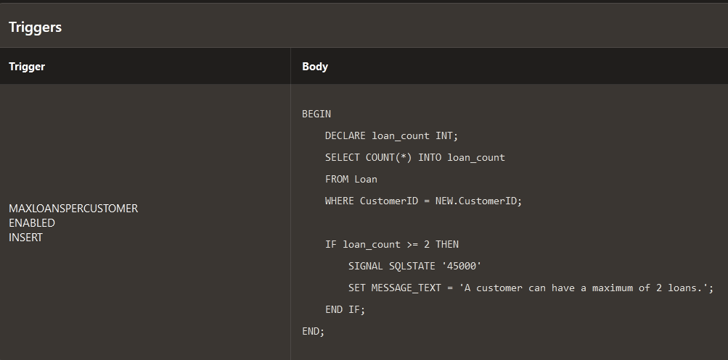

1. Give all the account details of a person who has accounts in SBI.

SELECT * FROM Account

WHERE Branch_ID IN (SELECT Branch_ID FROM Branch WHERE Bank_ID = (SELECT Bank_ID FROM Bank WHERE Bank_Name = 'SBI'));

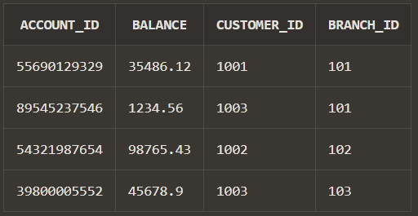

1. Find the account holder name who has more than 2 accounts.

SELECT Customer_Name FROM Customer

WHERE Customer_ID IN (SELECT Customer_ID FROM Account GROUP BY Customer_ID HAVING COUNT(Account_ID) > 2);

1. Rename the accounts table as account details.

ALTER TABLE Account RENAME TO Account_Details;

1. Find the loan amount and loan taken from which bank for each account holder.

SELECT C.Customer_Name, L.Loan_Amount, B.Bank_Name FROM Loan L

JOIN Customer C ON L.Customer_ID = C.Customer_ID

JOIN Branch Br ON L.Branch_ID = Br.Branch_ID

JOIN Bank B ON Br.Bank_ID = B.Bank_ID;

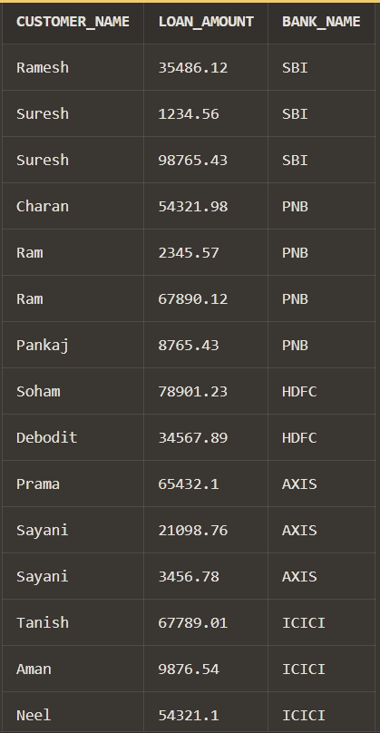

1. Find the account no. and account holder name who has not taken any loan.

SELECT A.Account_ID, C.Customer_Name FROM Account_Details A

JOIN Customer C ON A.Customer_ID = C.Customer_ID

WHERE A.Customer_ID NOT IN (SELECT Customer_ID FROM Loan);

1. Delete the account of all the persons who had accounts in PNB, Sealdah branch.

DELETE FROM Account_Details WHERE Branch_ID IN (SELECT Branch_ID FROM Branch WHERE Bank_ID = (SELECT Bank_ID FROM Bank WHERE Bank_Name = 'PNB') AND Branch_Name = 'Sealdah');

1. Update the branch to SBI, Salt Lake branch for all the persons who had a SBI account in Sealdah branch.

UPDATE Account_Details

SET Branch_ID = (SELECT Branch_ID FROM Branch WHERE Branch_Name = 'Salt Lake' AND Bank_ID = (SELECT Bank_ID FROM Bank WHERE Bank_Name = 'SBI'))

WHERE Branch_ID = (SELECT Branch_ID FROM Branch WHERE Branch_Name = 'Sealdah' AND Bank_ID = (SELECT Bank_ID FROM Bank WHERE Bank_Name = 'SBI'));

1. Find the maximum account balance of a person with account no 54321987654 among all of his accounts.

SELECT MAX(Balance) AS Max_Balance

FROM Account_Details WHERE

Customer_ID = (SELECT Customer_ID FROM Account_Details WHERE Account_ID = 54321987654);

